**FACULTY PROFILE**

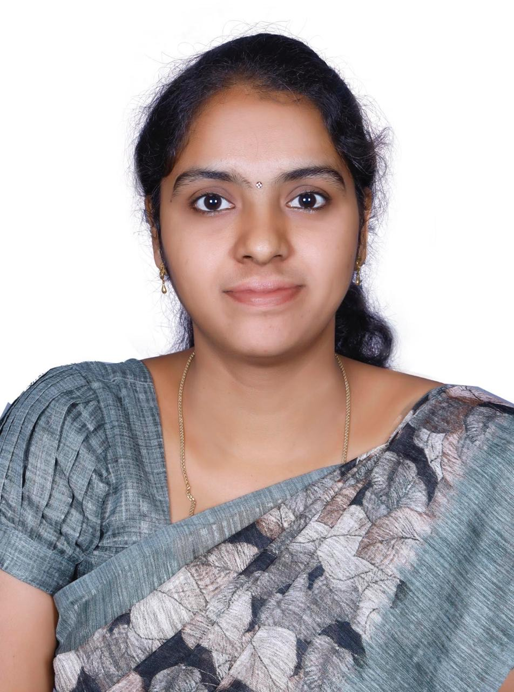OTO

|  |  |  |
| --- | --- | --- |
| **Name** | : | Dr.S. DURAIESWARI |
| **Area of Specialisation** | : | Commerce - Marketing |
| **Education** | : | M.Com(CA).,M.Phil.,PhD |
| **Other Qualifications** | : |  |
| **Professional Experience (in years)** | | | |
| **Teaching** | : | **3 1/2 yrs** | |
| **Contact Details** | | | |
| **Mobile** | : | **9788941152** | |
| **E-mail** | : | **duraieswari@psgrkcw.ac.in** | |
| **IRINS Link** | : | **https://psgrkcw.irins.org/profile/220548** | |
| **Professional Highlights** | | | |
| **Publications – Articles** |  |  | |
| **UGC** | : | 30 | |
| **SCOPUS-indexed** | : | 0 | |
| **Publications – Books & Chapters** | | | |
| **Books Published as Co-Author** | : | **1** | |