**FACULTY PROFILE**

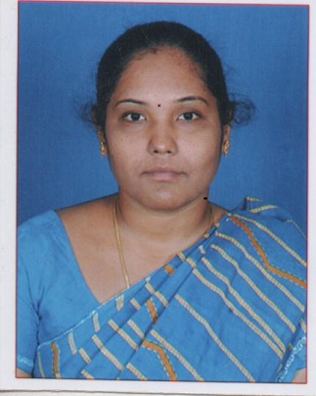

|  |  |  |
| --- | --- | --- |
| **Name** | : | **Dr. M.Yasodha** |
| **Area of Specialisation** | : | **Finance** |
| **Education** | : | **M.Com.,M.Com(CA).,M.Phil.,PGDCA,Ph.D** |
| **Other Qualifications** | : |  |
| **Professional Experience (in years)** | | | |
| **Teaching** | : | **9 yrs.** | |
| **Contact Details** | | | |
| **Mobile** | : | **9790642337** | |
| **E-mail** | : | **yasodha@psgrkcw.ac.in** | |
| **IRINS Link** | : | **https://psgrkcw.irins.org/profile/111910** | |
| **Professional Highlights** | | | |
| **Publications – Articles** |  |  | |
| **UGC** | : | 21 | |
| **SCOPUS-indexed** | : | 2 | |
| **Seminar Proceedings** | : | 10 | |
|  |  |  | |

|  |
| --- |
| **Academic Administrative Responsibilities (in Descending Chronological Order)** |
| 1. Yuva Club Co-ordinator |

|  |  |  |
| --- | --- | --- |
|  |  |  |
|  |  |  |
|  | | |
|  | | |